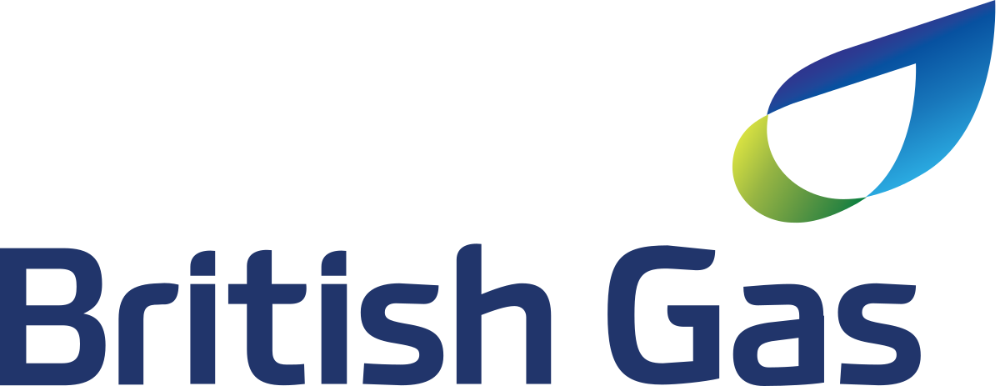

Robert Plumb

**www.robertplumb.info**

emailplumb@gmail.com

My passion for great user experience combined with a strong curiosity in experimentation, rapid testing and innovation, along with my visual design talent, motivates me to constantly acquire knowledge and develop new skills, whilst embracing the design and commercial challenges associated with rapid advances of modern technology and changes in user behaviour.

My time at Centrica Hive Limited has grown my enthusiasm for data-driven products and services, fuelling my obsession to understand user behaviour, together with current and future commercial trends, via customer research, user testing and industry insights, to define and validate product feature requirements/improvements.

My proven history working for many top brands has taught me the importance of brand identity, attention to detail, and adherence to brand values including tone of voice.

Senior UX Designer

Dec 2020 - May 2022

A Centrica reorganisation resulted in my previous employment at Hive being merged into a new British Gas structure, and although my job title changed, I continued working in my previous role for Hive.

I took on the design lead for Hive customer account self-serve development. I designed a range of App and Web features to reduce the need for customers to contact the Hive Hub call centre, reducing costs to the business, improve CX and increase upsell opportunities.  
  
This included delivering:

* **Self-serve subscriptions management**
* **Subscriptions upsell**
* **Utilising BOXEVER data for bespoke product & service upsell**
* **B2B2C subscription partnerships**
* **Informative order tracking**
* **Improved returns process**
* **Simplifying EV charger installation appointments & onboarding**
* **Self-help/self-fix in-app troubleshooting journey across all Hive products & services**

I was also leading account design activities required for Hive’s future road map into NetZero energy management, this included an holistic design view of Hive EV charging for both engineer home installation and customer onboarding experience.  
  
I also continued to be the ‘go-to’ person for providing Hive branded design support for customer engagement, both marketing and service related touchpoints, including email comms.

Employment history

Curriculum vitae

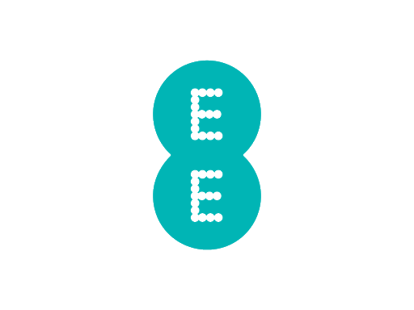

Lead Product Designer

Oct 2013 - Dec 2020

Initially employed as a contract UX/UI Designer at Centrica Hive Limited, developing the Hive app and website. After five months, I soon realised that data driven IoT products were what I wanted to be involved in on a full-time basis. I accepted a permanent position in 2014 and concentrated on leading the UI design and CX of smart diagnostics products for both customers and engineers, simplifying complex information into useful and easy to understand, user friendly experiences.  
  
This included delivering:

* **Boiler IQ - Onboarding improvements**
* **Boiler IQ - Hive app implementation**
* **Boiler IQ - Engineer installation app and training aids**
* **Engineer & call centre agent remote diagnostics teaching aids**
* **Hive app insights and enhanced features for customer engagement**
* **Hive app troubleshooting/self-fix features**
* **Boiler IQ Lite - A viable solution to upscale the proposition and meet business requirements**
* **Hive Leak - Hive app leak detection implementation**
* **Hive Leak - Onboarding and troubleshooting improvements**
* **Water usage insights via monthly email and in-app real time data**
* **Commercial proposition delivering customer water usage insights to Utility companies**
* **Hive Leak - B2B2C subscription services**
* **HVAC - Similar proposition to Boiler IQ designed for Direct Energy customers with heating and aircon systems in North America**

Working in a lean/agile startup environment, my design responsibilities covered many disciplines, UX research, customer journey mapping, storyboarding, persona creation, prototyping, UI design - native and react native, specification guides, asset optimisation, art direction across all customer visual design touch points, internal presentations, and co-facilitated design workshops. I also managed printed related requests from user setup guides to engineer training manuals and supported customer/user research interviews/focus groups/testing.  
  
I helped build and implement the first Hive Design System named ‘Honey’, which had a huge impact on cost savings and design consistency, this drove many UX positive changes across the company.

Working within the Propositions Experience team, I enhanced activities by delivering quality stimuli in the form of visual concepts, prototypes, storyboards and end-to-end experience documentation/service design blueprints, to communicate new commercial opportunities and inspire stakeholders into holistic ways of problem-solving. Co-facilitated and contributed to many service design workshops engaging stakeholders and promoting innovation-led thinking. Provided design expertise and evaluations for post-launch products and services, whilst recommending immediate and future enhancements to improve the CX.

Service Design Specialist

Jul 2011 - Aug 2013

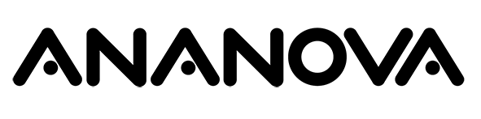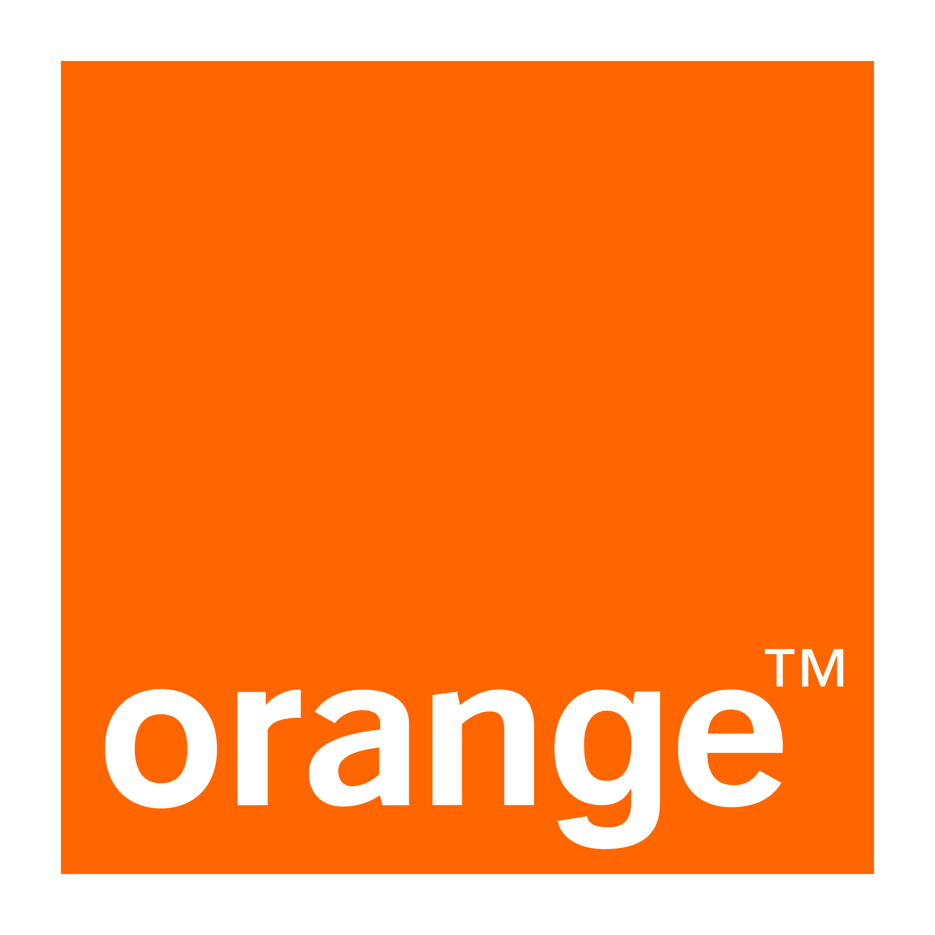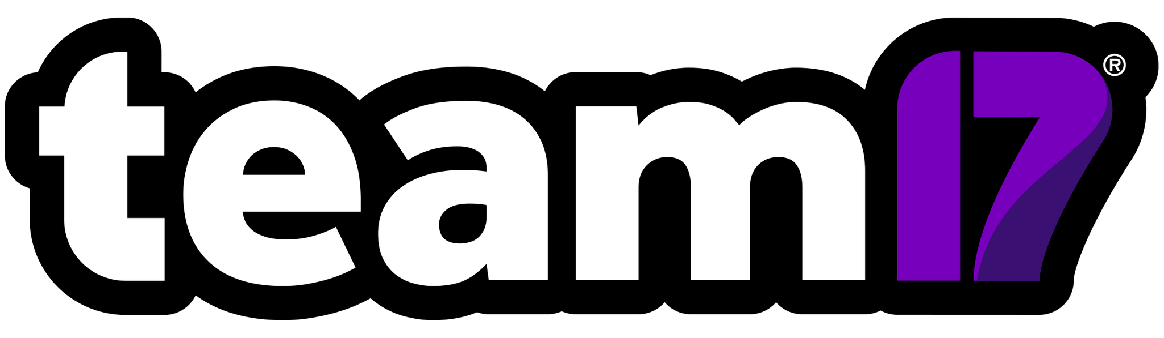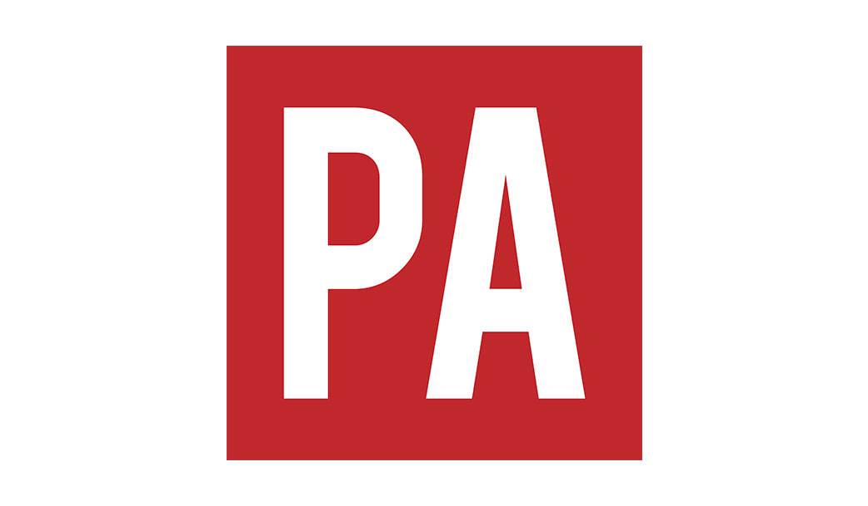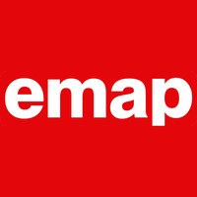

Multimedia Designer

1998 - 2000

Graphic Artist

1994 - 1996

Before smartphones, working in the Design & Usability team, I supported the development of the Orange World mobile portal into a major customer touchpoint. Produced wireframes of page flows and information architecture, digital asset creation, as well as visual page designs, interaction guides, style guides and documentation to support the successful delivery across all devices. This naturally evolved my career into leading the design of commercial and self-serve Apps for Orange. I have been fortunate to engage with almost every part of the business, from designing webpages for orange.co.uk to out-of-box Easy setup guides and other brand marketing material.

PA New Media, the multimedia division of The Press Association. I mainly worked on website design for clients who bought content from PA. Some of the websites I was involved in designing back then included: PA Sport, PA Weather, PA Listings, PA Photos, The Royal Family, The Prince's Trust, The Duchy of Cornwall, Sporting Life, The Football League, BT Cellnet. Other digital projects included WebTV and Interactive Kiosks, I also undertook print work and brand guardianship for the PA companies via guidelines documentation creation.

Senior Product Designer

2001 - 2011

Played a senior role within the design team creating the Ananova brand, avatar and website. Formerly known as PA New Media, the company was one of the leading providers of ready-for-publication packages of news, sport, entertainment, events listings and other real-time information for websites, WAP sites and digital TV. The news alert service covered over 3000 subjects, which was delivered to users via website personalisation, email, PDAs, WAP and SMS. Ananova was recognised by Guinness World Records as the world's first virtual newscaster and was later acquired by Orange.

Senior Designer

2000 - 2001

I initially joined Team17's multimedia department supporting the creation and optimisation of graphic assets for it's CD Rom titles. In the very early days of the internet we noticed that many video games users were early adopters and a company website was a powerful new method in communicating with these customers, so through my own interest and passion to learn new skills I became the first Team17 website designer. I also helped to create one of the UK's first online shopping malls.

My first employment after graduation was working as a graphic artist and typesetter, creating adverts and infographics for one daily and ten weekly news publication titles.​

Multimedia Designer

1996 - 1998



Volunteering

Volunteer digital artist and web design consultant for the Imperial War Museum in Duxford.

Digital Design Consultant

00

* Prototyping - paper & digital
* Sketch & Figma
* Adobe Ai - Id - Lr - Ps
* JIRA - Trello - Miro - Slack
* Keynote/Powerpoint
* Photography
* Illustration & infographics
* Customer labs & usability tests
* Brand & style guide creation
* Asset creation & optimisation
* Print production
* Print project management
* Atomic design systems
* Service design methodologies
* UCD methodologies
* Lean agile/Waterfall processes
* Native app UX/UI design
* Web app & Web design

Skills & Knowledge

00

00

Other interests

I enjoy making homemade cider, wine and vodka liqueurs using fruit grown from my home, close to the North York Moors National Park. I'm a keen photographer, I love vegetarian cooking and regularly visiting the Far East, especially Singapore, where I get my inspiration for forward thinking UCD. I love experiencing premium aviation products and services which is only possible through my interest and extensive knowledge of loyalty airmiles programs. I'm also a practising Buddhist, I have been studying Buddhist philosophy and meditation for nearly twenty years.

De Montfort University Leicester

1990 - 1993

B-Tec First Diploma in Design

00

BA Hons Graphic Design

1987 - 1988

Education

1988 - 1990

Scarborough Technical College

B-Tec National Diploma in Graphic Design & Photography

Scarborough Technical College

2004 - 2012